Production environment

Server: miasx1
IP: 180.201.151.152
T24 Production environment: MIAPRD
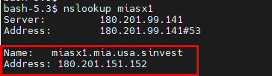
T24 Desktop:
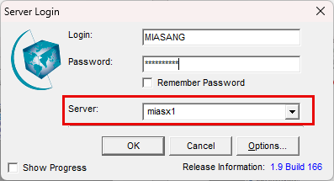

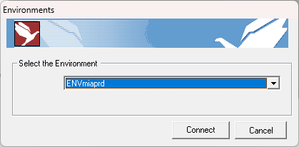

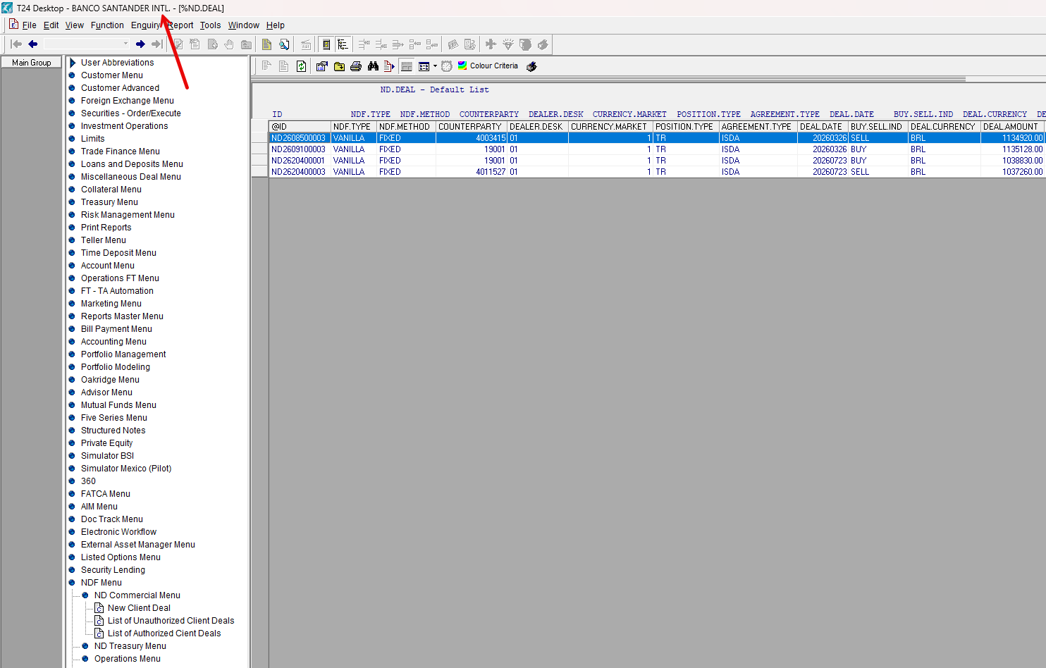

Non-production environment

Different Server, IP and T24 environment than Production:

Server: miasx4
IP: 180.201.1.156
Non-production environment: MIAAFT28
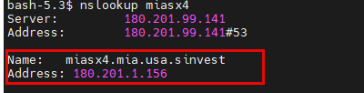
T24 Desktop:
